MEMORANDUM OF UNDERSTANDING
for the establishment of a competitive Regional Electricity Market (REM)
in South Eastern Europe
Athens, June 2, 2000
 | The undersigned:
Minister of Public Economy and Privatisation of the Republic of Albania
Mr. Mustafa Muci
Minister of Foreign Trade and Economic Relations of Bosnia and Herzegovina
Mr. Mirsad Kurtovic
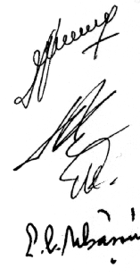 |  | President of the State Agency for Energy and Energy Resources of the Republic of Bulgaria  Mr. Ivan Shiliashki
Secretary of State of the Ministry of Industry and Commerce of Romania
Mr. Eugen Constantin Isbasoiu
Minister of Economy of the former Yugoslav Republic of Macedonia
Mr. Borko Andreev
Minister of Development of the Hellenic Republic
Prof. Nikolaos Christodoulakis

A. | Declaration of Intent for the establishment of a competitive Regional Electricity Market (REM) in South Eastern Europe, signed in Thessaloniki on September 10, 1999, and approving the ongoing procedures of the REM Management Committee to prepare a second, more detailed Declaration for a phased development of REM, according to its mandate as described in the aforementioned Declaration;
B. | Being aware of the fact that, in addition to the initiative to establish the REM in South Eastern Europe, there are, at least three other initiatives in the region with a similar intention (the SECI project on development of interconnections of electric power systems, the Canadian-financed Southeast European Electrical System Technical Support Project and the Black Sea Economic Co-operation initiative). Furthermore, there is a list of projects included in the lists of Table II of the Stability Pact, the European Investment Bank and the European Bank for Reconstruction and Development, which are also aiming at developing a regional electricity market;
C. | Considering that the existence of such parallel initiatives and actions could result in overlapping, duplication of effort, unnecessary waste of time and resources, and may create confusion, especially among possible investors and market players, in the whole region;
D. | Judging, therefore, that it is necessary to:
  1. | ensure that all initiatives to develop a Regional Electricity Market in South Eastern Europe are co-ordinated;
  2. | benefit from the considerable advance of the European Union initiated competitive REM in South Eastern Europe;

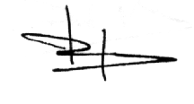

express, with this Memorandum, their common understanding of the issues that have to be dealt with, in order to establish the REM, and agreed as follows:
1. | The signing of the Thessaloniki Declaration has created a positive momentum, that was enhanced by the commitment of the countries of the region and the partners of the Stability Pact to work together for peace, stability and prosperity in South Eastern Europe;
2. | In order to avoid overlapping or duplication of efforts, it is necessary to secure co-ordination of all initiatives related to or promoting the establishment of a REM;
3. | The initiative is open to all countries of the region, if they express their interest in joining;
4. | Proceed to a Ministerial meeting of the REM countries, the European Commission and representatives of all relevant initiatives. This Ministerial meeting, properly prepared should take place in the last quarter of this year;
5. | The undersigned recommend the continuation of the work of the REM-MC in order to finalise a second Declaration with the view to adopting it in the next Ministerial Meeting;
6. | Hellas, as a Member State of the European Union, will take the initiative to co-operate closely with the European Commission for continued support in the implementation of the Regional Electricity Market.
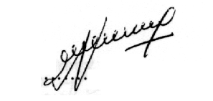  …………………………………………  For the Republic of Albania  Mr. Mustafa Muci | 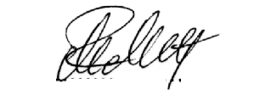  …………………………………………….  For Bosnia and Herzegovina  Mr. Mirsad Kurtovic
…………………………………………….  For the Republic of Bulgaria  Mr. Ivan Shiliashki | 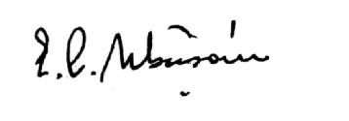  …………………………………………….  For Romania  Mr. Eugen Constantin Isbasoiu
…………………………………………..  For the former Yugoslav Republic  of Macedonia  Mr. Borko Andreev | 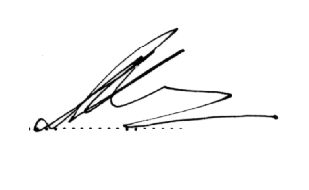  …………………………………………….  For the Hellenic Republic  Prof. Nikolaos Christodoulakis
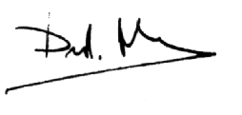
REPUBLIKA MAKEDONIJA MINISTERSTVO ZA STOPANSTVO |  | REPUBLIC OF MACEDONIA  MINISTRY OF ECONOMY

Athens, June 2, 2000
Sirs,
I have the honour to confirm that the text "REM Memorandum of Understanding" is acceptable by the Macedonian Government. With this letter the Government of the Republic of Macedonia considers itself as a signatory of the Memorandum.
This acceptance of the Government of the Republic of Macedonia that the Memorandum with the Statements is signed by this Memorandum, does not prejudice that the Government of the Republic of Macedonia accepts to refer to itself otherwise than its constitutional name.
